Unit 7—Chart Building

**Corey Crooks**

**Purdue University Global**

**IT350 – Advanced Database Concepts**

**Jason Johnson**

**March 22nd, 2023**

**Charts and Queries**

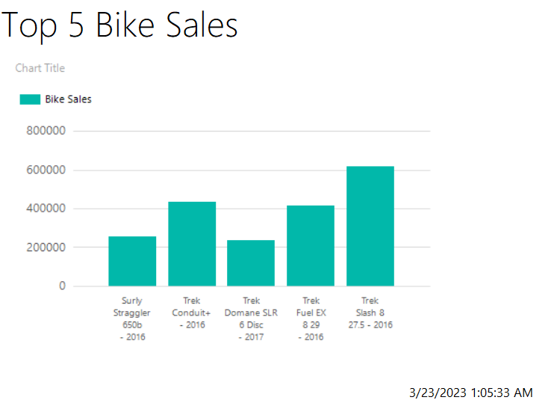

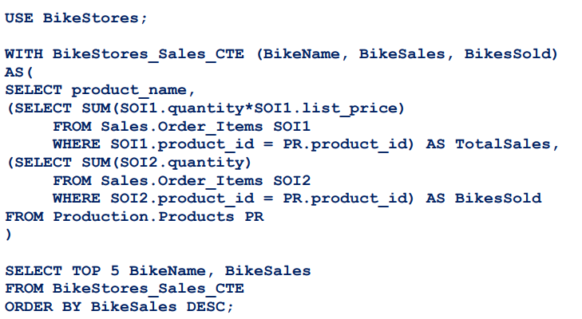

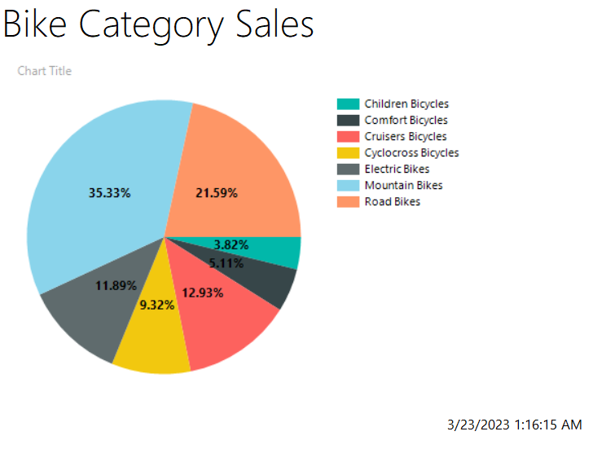

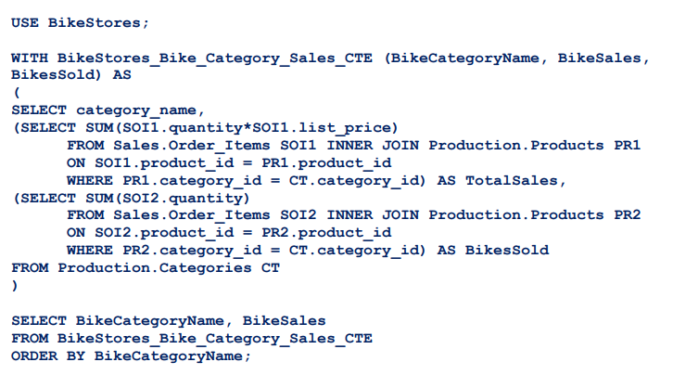

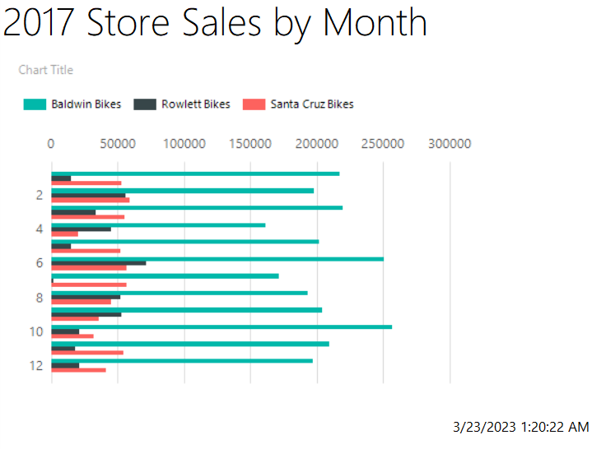

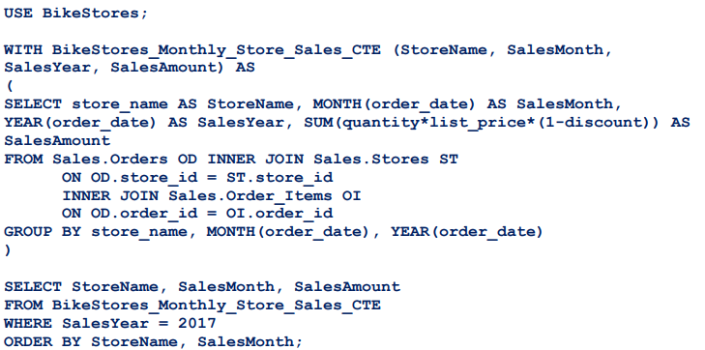

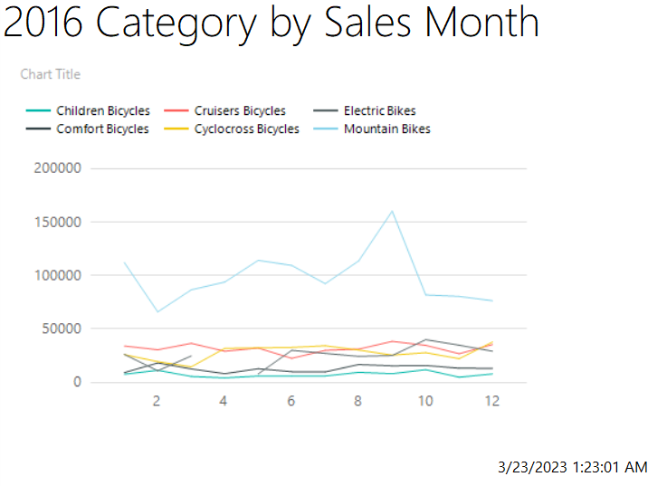

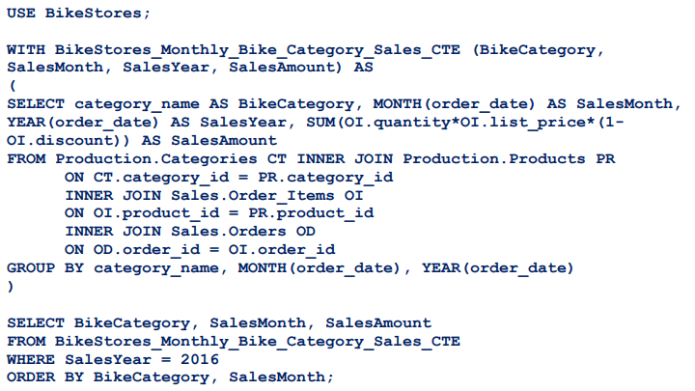

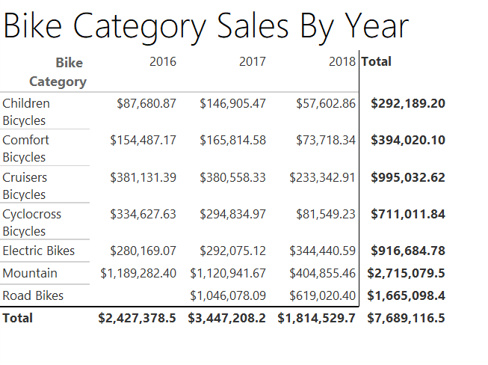 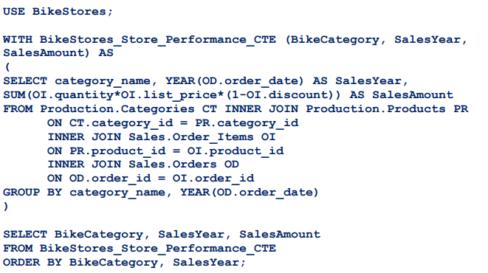

**Research Questions**

* **Relating to common table expressions (CTE’s), are correlated or uncorrelated subqueries leveraged?**

Common table expressions are a relatively complex, but common way to organize and display data. Due to their limitations, they are unable to utilize correlated subqueries (Weese, n.d.); that is, they cannot use subqueries that rely on external query data.

* **Are the query results filtered? If they are, how so?**

As seen in the queries themselves, they do have a number of mechanisms to filter data. For example, charts 3 and 4 utilize a WHERE SQL clause which filters the data found within the query as specified by each WHERE clause.

* **Are table joins used in the query? If so, which tables are linked together?**

Although not every table is linked, there are some joins happening in some of these charts. Chart 2 features inner joins on the Sales.Order_Items and Production.Products. Chart 3 features an inner join on Sales.Orders, Sales.Stores, and Sales.Order_Items. Chart 4 features inner joins on Production.Categories, Production.Products,Sales.Order_Items, Production.Products.product_id, and Sales.Orders order_id.

* **Are aggregate functions leveraged in the query? If so, describe what results are being sought along with the applicable grouping parameters.**

There are aggregate functions utilized in each of these charts. For starters, to display the data, the chart creator (or tabulate view creator) requires a SUM aggregate function for a comprehensive readout of the input data. In addition, there are aggregate functions found within the query text themselves. Chart 1’s query utilizes two SUM functions, chart 2’s query utilizes two SUM functions, chart 3’s query utilizes a single SUM function, chart 4’s query utilizes a single SUM function, and chart 5 utilizes just one SUM function.

# **References**

Weese, J. (n.d.). *Common Table Expressions*. Retrieved from Kansase State University: https://textbooks.cs.ksu.edu/cc520/06-table-expressions/3-common-table-expressions/